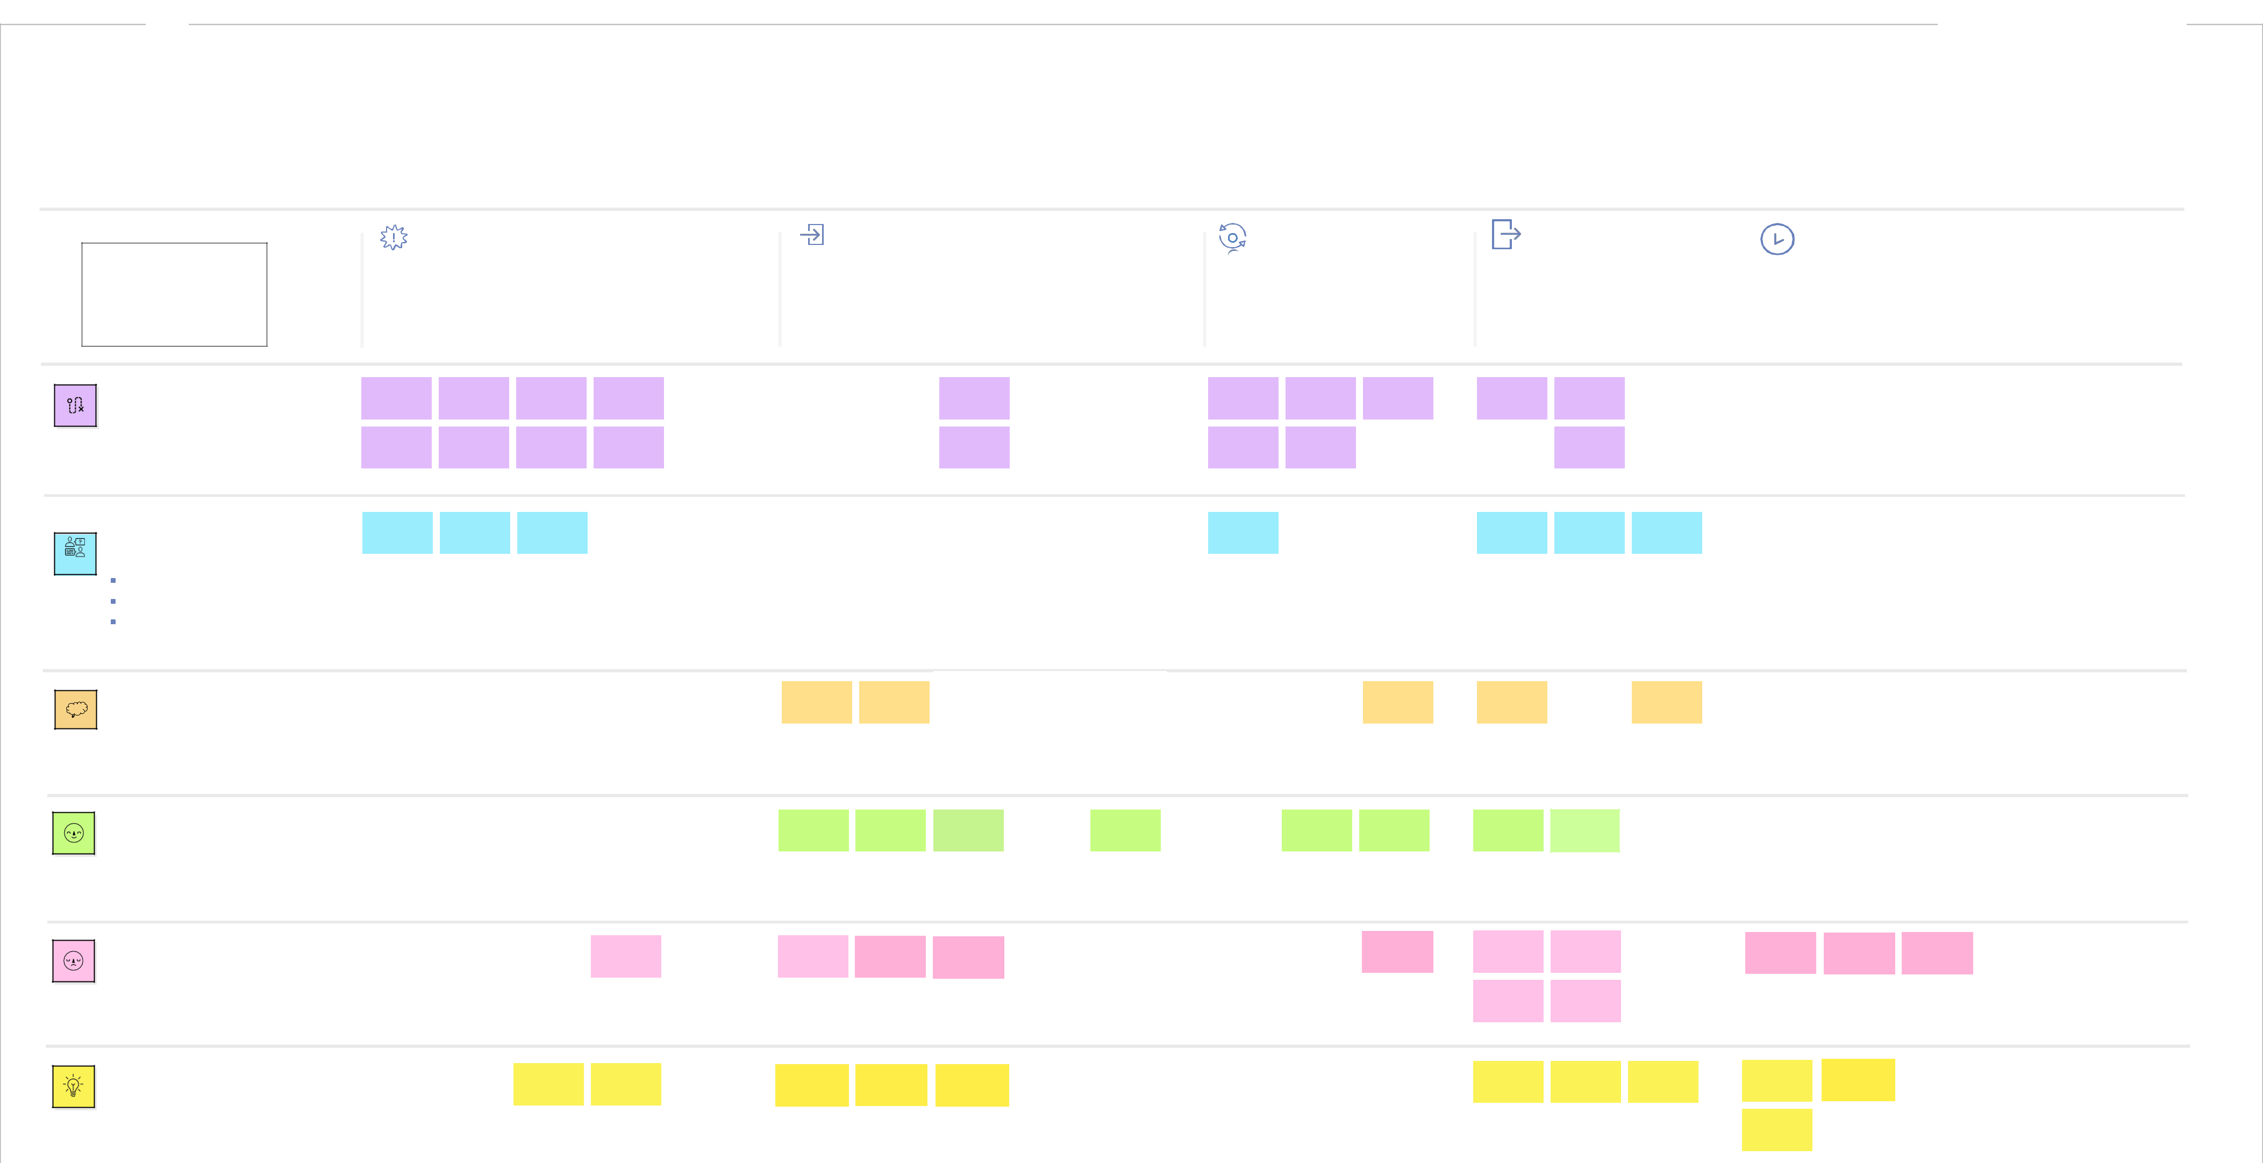

**HANDWRITTEN DIGIT RECOGNITION**

**Upload the**

**handwritten digit**

**image and recognise**

**the digit**

**Entice**

How does someone

initially become aware

of this process?

Enter

What do people

experience as they

begin the process?

Engage

In the core moments

in the process, what

happens?

|  |  |
| --- | --- |
| Exit | Extend |
| What do people | What happens after the |
| typically experience | experience is over? |
| as the process finishes? |  |
|  |  |

**Steps**

What does the person (or group)

typically experience?

**Interactions**

What interactions do they have at each step along the way?

**People:** Who do they see or talk to?

**Places:** Where are they?

**Things:** What digital touchpoints or physical objects would they use?

Visit website

The customer navigates

to the upload section of

our website

Upload image

section of the

website

Upload the

image

The customer once visits the website then upload the image

Scan image section

on website

Preprocessing

Perform various task on the image is to take of the fascinating.

Digitized output section

of the image.

segmentation

Pre-processed image segment into sub image of individual digit where assign the number of each digit.

|  |  |  |  |  |
| --- | --- | --- | --- | --- |
|  |  |  |  |  |
|  |  | Start uploading |  | Scanning the |
|  |  |  |  | image |
|  |  |  |  |  |
|  |  |  | |  |
|  |  | If the customer wants |  | he will upload it or else |
|  |  | to upload the image, |  | he will scan it |
|  |  | he will upload it or else |  |  |
|  |  | he will scan it |  |  |
|  |  |  |  |  |
|  |  |  |  |  |

|  |  |  |
| --- | --- | --- |
| Upload or scan image |  | Output section |
| section of the website |  |  |
|  |  |  |

Experience the

output

The customer will

view the digitized

output.

Checking

the image

Checks whether

customer has uploaded

the correct handwritten

image

Pop up message of

website

After the correct

Process the image recognition of digits, the customer

will be satisfied.

After checking the

image, it will start

processing the image.

|  |  |  |  |
| --- | --- | --- | --- |
| Output section of |  | When they try to |  |
| the website |  | upload the input |  |
|  |  |  |
|  |  |  |  |
|  |  |  |  |
|  |  |  |  |
|  |  |  |  |
|  |  |  |  |

Leave the

website

Can leave

feedback

Writing &

submitting

review

After successful recognition of digits, the customer will be satisfied, since they got their recognized digits correctly

Close the web or

use it again

Use the upload option again to recognize digits repeatedly

|  |  |  |  |  |  |  |  |  |
| --- | --- | --- | --- | --- | --- | --- | --- | --- |
| Personalized |  | Compare their |  | The user can |  | Use it whenever |  |  |
|  |  |  | the situation to |  |  |
| Recommendation |  | expectations and |  | think of any |  |  |  |
|  | actual experience |  |  | digit recognition |  |  |
|  |  |  | improvement |  |  |  |
|  |  |  |  |  | arises |  |  |
|  |  |  |  |  |  |  |  |
|  |  |  |  |  |  |  |  |  |
|  |  |  |  |  |  |  |  |  |
|  |  |  |  |  |  |  |  |  |

|  |  |  |  |  |
| --- | --- | --- | --- | --- |
| Recommendation |  | Interact with people |  | At their workplace |
| span across |  | who might find this |  | or workers get- |
| website |  | useful |  | togethers |
|  |  |  |  |  |
|  |  |  |  |  |
|  |  |  |  |  |

**Goals & motivations**

At each step, what is a person’s primary goal or motivation? (“Help me...” or “Help me avoid...”)

**Positive moments**

What steps does a typical person find enjoyable, productive, fun, motivating, delightful, or exciting?

**Negative moments**

What steps does a typical person find frustrating, confusing, angering, costly, or time-consuming?

|  |  |  |  |  |  |
| --- | --- | --- | --- | --- | --- |
| Help me to find the |  | Help me to identify |  | Help me to avoid |  |
|  |  | wrong recognition of |  |
| right website |  | handwritten digits |  |  |
|  |  | handwritten digits |  |
|  |  |  |  |  |
|  |  |  |  |  |  |

|  |  |  |  |  |  |  |
| --- | --- | --- | --- | --- | --- | --- |
|  |  | When the image is |  | It excites when the |  |  |
|  |  | perfectly uploaded |  |  |  |
|  |  |  | digits when the |  |  |
|  |  |  |  |  |  |
|  |  |  |  | recognized correctly. |  |  |
|  |  |  |  |  |  |  |
|  |  |  |  |  |  |  |
|  |  |  |  | It's productivity when |  |  |
|  |  |  |  | the digits are |  |  |
|  |  |  |  | recognized fast |  |  |
|  |  |  |  |  |  |  |
|  |  |  |  |  |  |  |
| People sometimes upload |  | People express a bit of | | There is not clear |  |  |
|  | description on what |  |  |
| wrong image |  | fear of digits to be | | the working of the |  |  |
|  |  | recognized correctly | |  |  |
|  |  | system is |  |  |
|  |  |  |  |  |  |
|  |  |  |  |  |  |  |

Help me to upload or scan the image

Excitement for the digit

recognition

**("Here we go!")**

People might feel

difficult to upload

/scan the image

Help me to recognize

the digits

Upload the image without any trouble

There are problems with login and server might crash

Login quickly and

without any stand-

ups

People might enter

wrong data and faulty

data gets inputted

It’s very essential

to get correct

recognized of the

digits

|  |  |  |
| --- | --- | --- |
| Help me to check |  | Help me to feel |
| whether the upload |  | confident about |
| image is correct or not |  | recognized digits |
|  |  |  |

This application tends to

be good since the digits

are recognized correctly

|  |  |  |
| --- | --- | --- |
| Some people are |  | People feel peer |
| unclear while |  | pressure while the |
| upgrading or |  | image is being |
| scanning the image |  | processed |
|  |  |  |

Process the images

quickly

Get a satisfaction

after getting correct

result

When processing data and producing output takes quite a time frustration occurs

Help me leave the

website with good

feelings and

satisfaction.

People while

leaving, will have

completed their

purpose

When they have

wrong output

When the process

took too long to

finish and user

leaves irritated

Make the experience

smooth and error

free

User gets happy

when the entire

process runs

smoothly

|  |  |
| --- | --- |
|  | When their actual |
| Customers report | experience is not |
| feeling review | on par with |
| fatigue | expectation |
|  |  |

We have very low review

rates, few people only

engage with the

feedback system

|  |  |  |  |  |
| --- | --- | --- | --- | --- |
|  |  | Make me think |  | Make it easier to |
| Help me to suggest |  | about more |  | share this to others |
| others to make |  | features, to show |  |  |
| use of this |  | its possible to add |  |  |
|  |  | them |  |  |

|  |  |  |  |  |  |
| --- | --- | --- | --- | --- | --- |
|  | Happy upon seeing new |  |  | Becomes useful to |  |
|  |  |  |  |  |
|  | features and improvements |  |  | others who were |  |
|  | get added |  |  | recommended to this |  |
|  |  |  |  |  |
|  |  |  |  |  |  |
|  |  |  |  |  |  |
|  | People become happy |  |  |  |  |
|  | when the digits are |  |  |  |  |
|  | recognised correct |  |  |  |  |
|  |  |  |  | |  |
|  | Other colleagues do | There is no room for | The engagement is | |  |
|  | not find this useful | improvement | very low and no | |  |

sharing about the

system

**Areas of opportunity**

How might we make each step

better? What ideas do we have?

What have others suggested?

|  |  |  |
| --- | --- | --- |
| Could we get | Should find the | Display the key |
| more detailed | target audience | features and |
| description |  | main points |
|  |  |  |

Could we check if

we uploaded the

correct image

Could we get

message if we got

the data right

Could we have all

the data and

uploaded inputs in

dashboard

|  |  |  |  |  |
| --- | --- | --- | --- | --- |
|  |  | Should set up |  | More training |
| Could we get help during |  | recovery measure in |  | to get better |
| any process |  | case of losing input |  | results |
|  |  | images |  |  |
|  |  |  |  |  |

Could we save

Can we get history the outputs of recognized digits

Could we save

|  |  |
| --- | --- |
| the progress | How might we know |
| while exiting and | that the customer feels |
| continue again | good and satisfied? |
|  | Could we |
|  | handle this on |
|  | multiple devices |

Could we get new

facilities to share

among peers